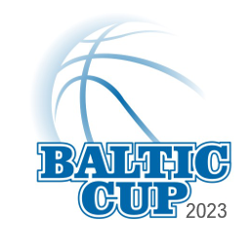
I, the undersigned voluntarily make and grant this waiver of liability and assumption of risk in favor of Baltic Cup organizers in relation to my participation in Baltic Cup‘23, September 29 – October 1, 2023 at Parnu (Estonia). In addition, I hereby release and forever discharge all entities associated with the tournament of and from all liabilities, claims, actions, damages, loss, costs or expenses including, but not limited to, all legal fees and disbursements.
I understand that the release and indemnity agreement includes any claims based on the negligence, action or inaction of any of the released parties and covers bodily injury (including death) and property damage, whether suffered by me, before, during or after such participation. I hereby certify that I am a competent person in good health assuming these risks of my own free will being under no compulsion or duress from others. The waiver of liability and assumption of risk is effective from the date below and shall continue in full force and effect following the completion of the tournament.

Teamname:_________________________________Date:______
- _______________________________________ Signature__________________
- _______________________________________ Signature__________________
- _______________________________________ Signature__________________
- _______________________________________ Signature__________________
- _______________________________________ Signature__________________
- _______________________________________ Signature__________________
- _______________________________________ Signature__________________
- _______________________________________ Signature__________________
- _______________________________________ Signature__________________
- _______________________________________ Signature__________________
- _______________________________________ Signature__________________
- _______________________________________ Signature__________________
- _______________________________________ Signature__________________
- _______________________________________ Signature__________________
- _______________________________________ Signature__________________
Note: All players at the Baltic Cup‘23 are strongly advised to arrange their own personal accident insurance prior to attending the tournament!
I, _________________________________ as this Team Manager approve, that my team’s members understand the content of the Waiver of Liability and it is signed by every Team’s member personally. __________________

